**Assignment 5**

**Description:**

1. Assume that you have the following JavaScript code:

Code – 1

<script>

function countRabbits() {

for(let i=1; i<=3; i++) {

alert("Rabbit number " + i);

}

}

</script>

<input type="button" onclick="countRabbits" value="Count rabbits!">

Code – 2

<button id="myBtn">Try it</button>

<script>

document.getElementById("myBtn").AddEventListener("click", function () {

this.style=backgroundColor = "red";

});

</script>

let’s format a message containing a string and an integer

**Show the output Code -1**

1. **Get the output of countRabbits() function and if you find the code and syntax error correct them.**
2. <!DOCTYPE html>
3. <html lang="en">
4. <head>
5. <meta charset="UTF-8">
6. <meta http-equiv="X-UA-Compatible" content="IE=edge">
7. <meta name="viewport" content="width=device-width, initial-scale=1.0">
8. <title>Document</title>
9. </head>
10. <body>
11. <script>
12. function countRabbits() {
13. for(let i=1; i<=3; i++) {
14. alert("Rabbit number " + i);
15. }
16. }
17. </script>
19. <input type="button" onclick="countRabbits()" value="Count rabbits!">
21. </body>
22. </html>
23. **Using this function able to count the value.**

Yes, this function consoled the value

**Output:**

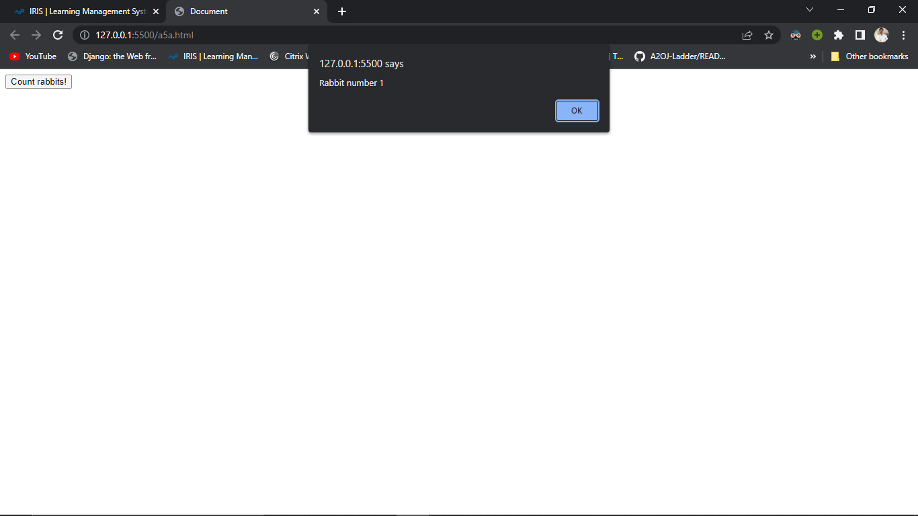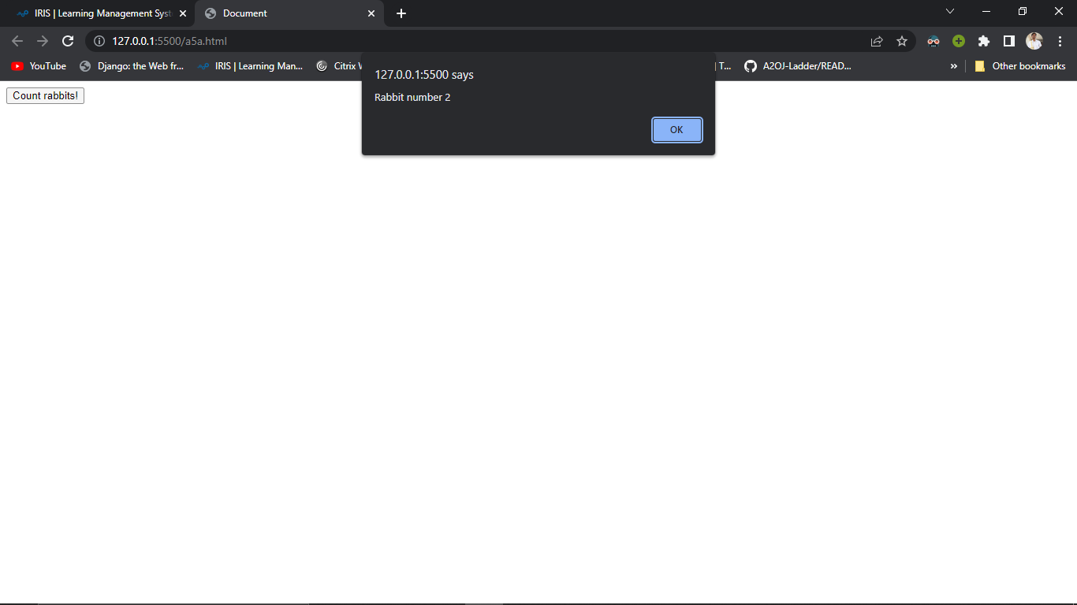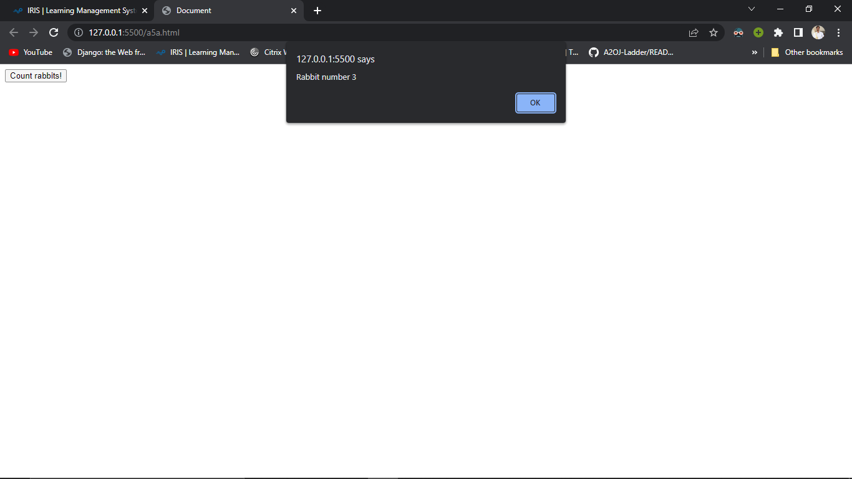

**Show the output Code -2**



1. **Get the output of code – 2 if there is any error find out the correct code snap.**
2. <!DOCTYPE html>
3. <html lang="en">
4. <head>
5. <meta charset="UTF-8">
6. <meta http-equiv="X-UA-Compatible" content="IE=edge">
7. <meta name="viewport" content="width=device-width, initial-scale=1.0">
8. <title>Document</title>
9. </head>
10. <body>
11. <button id="myBtn">Try it</button>
12. <script>
13. document.getElementById("myBtn").addEventListener("click", function () {
14. this.style.backgroundColor = "red";
15. });
16. </script>
17. </body>
18. </html>
19. **Event listener are able to change the color of mention element or not?**

**YES**

**Performance Outcomes:**

Upon successful completion of the assignment, the participant is well versed in

1. User are able use different function mechanism and use of them.
2. Able to know how can call a function on button click.
3. Use of action listener using javascript.
4. How can use or developer change the color of button on click event.